IV. Fourier Transform

Another useful transform is the Fourier transform:

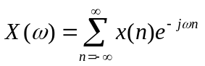

Note that 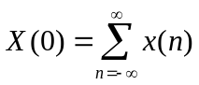 and 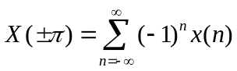.
It is easy to see that the Fourier transform is just the bilateral z transform when 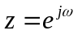; in other words, the Fourier transform is the z transform evaluated on the unit circle. If the ROC of the z transform includes the unit circle or, equivalently, if x is absolutely summable, the Fourier transform will have a finite magnitude. Note that the Fourier transform is always periodic with period 2π. This means that all the information in the Fourier transform is contained in an interval of length 2π on the ω axis. The inverse transform in the rational case can be found using a partial fraction expansion. Otherwise, we can use the inversion formula:

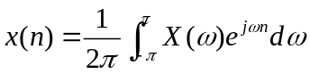

If x is real, its transform has conjugate symmetry:

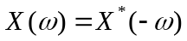

In this case, all the information in the transform is contained in the interval [0,π] on the ω axis, and the magnitude and angle are, respectively, even and odd functions of ω. If x is real and even, its transform is real and even. If x is real and odd, its transform is purely imaginary and odd.

It is sometimes convenient to work with the normalized frequency 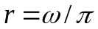; hence, r is the frequency in pi units. In this case,

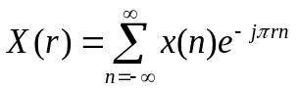

and, if x is real, all the information in the transform is contained in the interval [0,1] on the r axis.

The basic properties of the Fourier transform include:
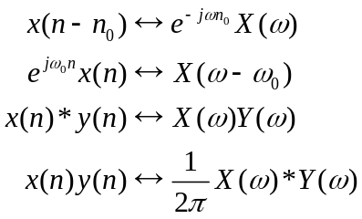

The convolution property is key to the Fourier analysis of LTI systems. Define the frequency response H as the Fourier transform of the impulse response h. The frequency response will exist if the system is stable (absolutely summable h). Then the input-output relationship is

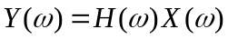

Input energy at frequencies where 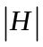 is small will be suppressed by the system. Remember that low frequencies are near ω = 0 and high frequencies are near ω = π.

Fourier analysis cannot incorporate initial conditions, so the output determined by the above equation is just the forced response and does not include the response due to the initial conditions. The forced response is the sum of two parts: a transient response that converges to zero, and a steady-state response that does not converge to zero. Suppose the input to a stable LTI system is 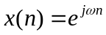. When there is no restriction on the range of n, we assume that the input was first applied in the remote past, so that the transients have disappeared. Then the steady-state response is

Now let the input be 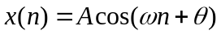. The steady-state response can be found easily using H. Write the input as:

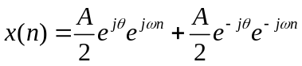

Then

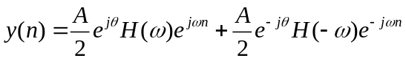
If h is real, 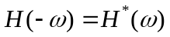 so the two terms in y are conjugates and

Therefore, the steady-state response is sinusoidal with the same frequency as the input. The amplitude and phase angle of the input are modified using the magnitude and phase angle of the frequency response at the input frequency.

Now suppose the LTI system is both stable and causal, and that a complex exponential input is applied starting at n = 0: 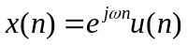. Then the output is zero for n < 0, and for 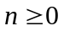,

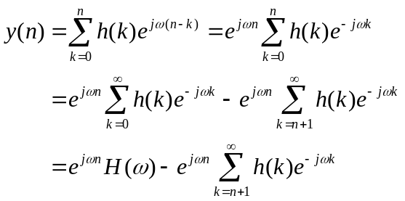

The first term is the steady-state portion of the forced response, and the second term is the transient portion of the forced response. In general, the transient portion does not disappear in finite time, but if the system is FIR and h(n) = 0 for n > M, then the transient portion is zero for 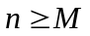, and the system reaches steady-state at time M.
Homework 4 (due 3 Oct.)

1. A causal LTI system has the difference equation model

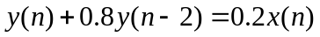

where x and y are the input and output, respectively. Determine the steady-state output when the input 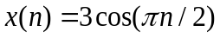.

2. For the system in problem 2 of homework 2: (a) Express the frequency response as a rational function of sin(ω/2). (b) Give an approximate formula for the frequency response for small ω. (c) What is the frequency response in the limiting cases 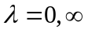? (d) The 3 dB cutoff frequency 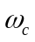 satisfies 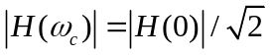. Express this frequency as a function of λ. What condition on λ guarantees the existence of ?

3. An LTI system has impulse response (centered at the origin):

Use Matlab’s roots function to determine which sinusoidal frequencies (expressed in pi units) are completely blocked in steady-state.

4. Let 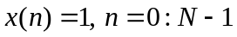. (a) Find 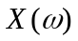 in closed form. (b) What is X(0)? (c) Where is equal to zero? (d) Plot 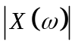 for N = 8, 16, 32 on one plot for 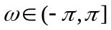.

5. (a) Use the result of the previous problem along with the Fourier transform modulation property to find the Fourier transform of 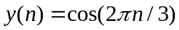, n = 0 : N-1. (b) Plot its magnitude for N = 8, 32, 128 on one plot for .

